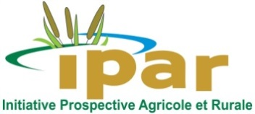
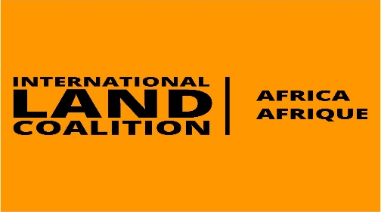
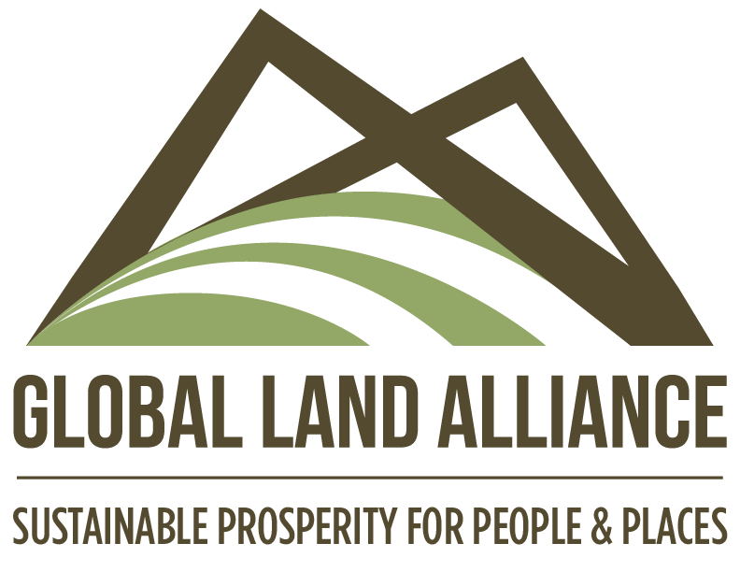

MEASURING LAND INSECURITY IN SUB-SAHARAN AFRICA: FROM EVIDENCE TO ACTION

Online Event over ZOOM - 2nd of December 2020, 10:00am – 12:00 pm GMT

Registration link: https://us02web.zoom.us/webinar/register/WN_fba0AC0ARSeW5ECApsWlXQ
Land insecurity is an issue everywhere. Since the outbreak of the COVID-19 global pandemic, the situation has likely deteriorated. The 2020 global comparative report of Prindex shows that rates of perceived insecurity vary from region to region around the world - the lowest rates are in Europe and Central Asia (12%), North America (14%) and East Asia and the Pacific (15%). Latin America and Caribbean (21%) is a little higher, and the Middle East and North Africa (28%) with the highest rates ». Within sub-Saharan Africa, with an average of 26 %, there is also a large range in insecurity rates, Rwanda being one of the lowest levels of insecurity worldwide with 8% and Burkina Faso among the highest with 44%.
This diversity within Africa can be explained by, among other reasons, the weaknesses of the legal systems, the overlapping or the superposition of statutory and customary tenure regimes, inefficiencies in the implementation of the legal procedures, poor land services delivery, as well as a lack of transparency and corruption issues. All of these issues are exacerbated in a context of a massive rush on arable agricultural lands and an increase in large scale land-based investments.
The Global Land Alliance (GLA), the International Land Coalition Africa (ILC Africa) and the Initiative Prospective Agricole et Rurale (IPAR) will be organizing an online regional event on measuring the land insecurity in Africa on the 2nd of December 2020.

This land and data-focused event will bring together the land actors in the region, decision makers at continental, regional and national levels, the National Statistical Offices, NGOs, academia, and land data experts for a rich discussion of how data on land insecurity can help improve decision-making.

We hope that different stakeholders will bring their unique perspectives on the importance of land insecurity measures to the table to actively attempt to address issues with collecting and using land-related data: quality and quantity of data, what data needs remain, what is being done in the field and how the evidence-based land policy approach can be more appropriated by all decision makers at all levels.
AIMS OF EVENT
- Present the key findings of the 2020 Prindex Sub-Saharan Africa comparative report (Prindex data on 36 countries in Sub-Saharan Africa)
- Bring land experts together with the continental development community to discuss the state of land security and property rights around the Sub-Saharan African region and how they can be strengthened.
- Engage decision makers to adopt the evidence-based land policy approach and tools such as LANDex, VGGTs and SDGs
- show how different data are complementary and how all the data efforts align to push Africa toward making better progress—more transparency, inclusion and accountability-- on the land agenda

EVENT PARTICIPANTS
- Guest of honour: Janet EDEME, Head of the Rural Economy Division of the AU Department of Rural Economy and Agriculture (AU DREA) to deliver opening remarks - TBC
- Moderator : Dr Cheikh Oumar BA, Executive Director of IPAR
- Speakers:
- Ibrahima KA, Africa Prindex regional coordinator, key findings from the 2020 Prindex regional comparative report (data from 34 countries)
- Clement ADJORLOLO, AUDA-NEPAD, Data’s perspective at continental level
- Ward ANSEEW, ILC, LANDex & global land governance monitoring/ use of Prindex's methodology
- Malcolm CHILDRESS, How Prindex contributes to tracking SDGs & VGGTs?
- Discussants
- Ruth MINJA, Tanzania's NSO, Role of NSOs in collecting and using of land data at national level
- Pr Taibat LAWANSON, need of disaggregated data at local level (Deep-dive in Nigeria)
- Esther MUIRU, Global women land rights advocate at ILC, perceptions on of women on their land security in case of divorce and death of the spouse in Africa

Time | What | Who
10:00-10:10 | Welcome, explain webinar setup, how Q&A works, etc. | Moderator
10:10-10:15 | Framing and Intro to panellists | Moderator
10:15-10:30 | Intro to Prindex | Ibrahima KA, ILC/IPAR
10:30-10:45 | Panellist #1 Data perspective at continental level | Clement ADORLOLO, AUDA NEPAD
10:45-11:00 | Panellist #2 Landex & use of Prindex’s methodology and data | Ward ANSEEW, ILC
11:00-11:15 | Panellist #3 how Prindex contributes to SDGs & VGGTs tracking? | Malcolm CHILDRES, GLA
11:15-11:25 | Q&R - Discussant #1 Role of the NSOs | Ruth MINJA, NSO Tanzania
11:20-11:30 | Q& R - Discussant #2 Data & WLR advocacy | Esther MUIRI, ILC
11:30-11:40 | Q&R - Discussant # 3 Deep dive | Pr TAIBAT, Nigeria
11:40-11:45 | Q&R – 1 or 2 Q from audience | Moderator
11:45 – 11:55 | Responses & last words from panelists | Moderator
11:55 – 12:00 | Closing remarks | Moderator

